NUCL 402 HMWK 10

1. Pressurizer Size for Surge

$$M_{maximumoutsurge}=17500 kg$$

$$M_{maximuminsurge}=9700 kg$$

$$Cold leg spray express as fraction of hot leg insurge \left(f\right)=[0.01:0.001:0.085]$$

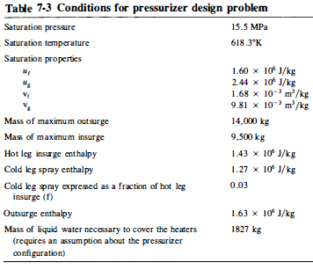

$${\left(Q_{h}\right)}_{insurge}=\frac{m_{surge}\left(1+f\right)\left[v_{g}u_{f}-v_{f}u_{g}\right]}{v_{g}-v_{f}}-m_{surge}\left(h_{surge}+fh_{spray}\right)$$

$$m_{g_{1}}=\frac{m_{surge}\left(1+f\right)v_{f}}{v_{g}-v_{f}}$$

$${\left(V_{g_{1}}\right)}_{insurge}=m_{g_{1}}v_{g}$$

$${\left(Q_{h}\right)}_{outsurge}=m_{surge}h_{surge}-\left(u_{f}-\frac{v_{f}}{v_{g}}u_{g}\right)\left(m_{surge}\frac{v_{g}}{v_{g}-v_{f}}\right)$$

$$m_{f_{1}}=m_{f_{2}}+m_{surge}\frac{v_{g}}{v_{g}-v_{f}}$$

$${\left(V_{f_{1}}\right)}_{outsurge}=m_{f_{1}}v_{f}$$

$$V_{T}={\left(V_{g_{1}}\right)}_{insurge}+{\left(V_{f_{1}}\right)}_{outsurge}$$

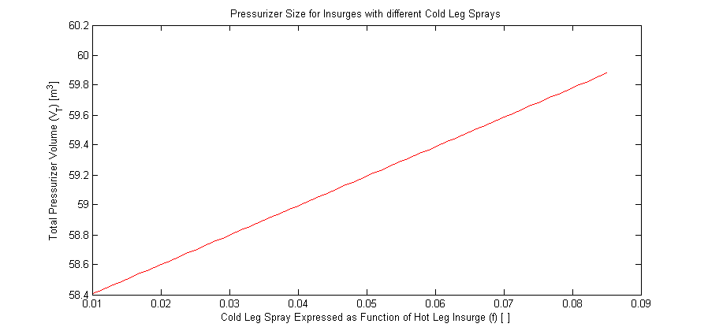

Figure 1 Pressurizer Size with Different Cold Leg Sprays

Code:

minsurge=9700; %maximum insurge mass in kg

f=0.01:0.001:0.085;

vf=1.68E-3; %saturation property for fluid in m^3/kg

vg=9.81E-3; %saturation property for gas in m^3/kg

mf2=1827; %mass of liquid water necessary to cover heaters in kg

moutsurge=17500; %maximum outsurge mass in kg

mg1=minsurge*(1+f)*vf/(vg-vf);

Vg1=mg1*vg;

mf1=mf2+moutsurge*vg/(vg-vf);

Vf1=mf1*vf;

Vtotal=Vg1+Vf1;

plot(f,Vtotal,'r-');

xlabel('Cold Leg Spray Expressed as Function of Hot Leg Insurge (f) [ ]');

ylabel('Total Pressurizer Volume (V_T) [m^3]');

title('Pressurizer Size for Insurges with different Cold Leg Sprays');